Project Design Phase-II
Data Flow Diagram & User Stories

Date | 04 July 2026
Team ID
Project Name | Personalised Networking Assistant
Maximum Marks | 4 Marks

Data Flow Diagrams:
The Data Flow Diagram (DFD) illustrates how data moves through the Personalized Networking Assistant system. The user enters event details and personal interests through the Streamlit interface, and this information is sent to the FastAPI backend for processing. The backend analyzes the input using KeyBERT with DistilBERT, generates personalized conversation topics, and performs fact-checking to ensure the information is reliable. The processed results are then returned to the user through the application interface. At the same time, the generated conversation history and user feedback are stored in a JSON file, enabling the system to maintain records and improve the overall user experience.
Example: (Simplified) 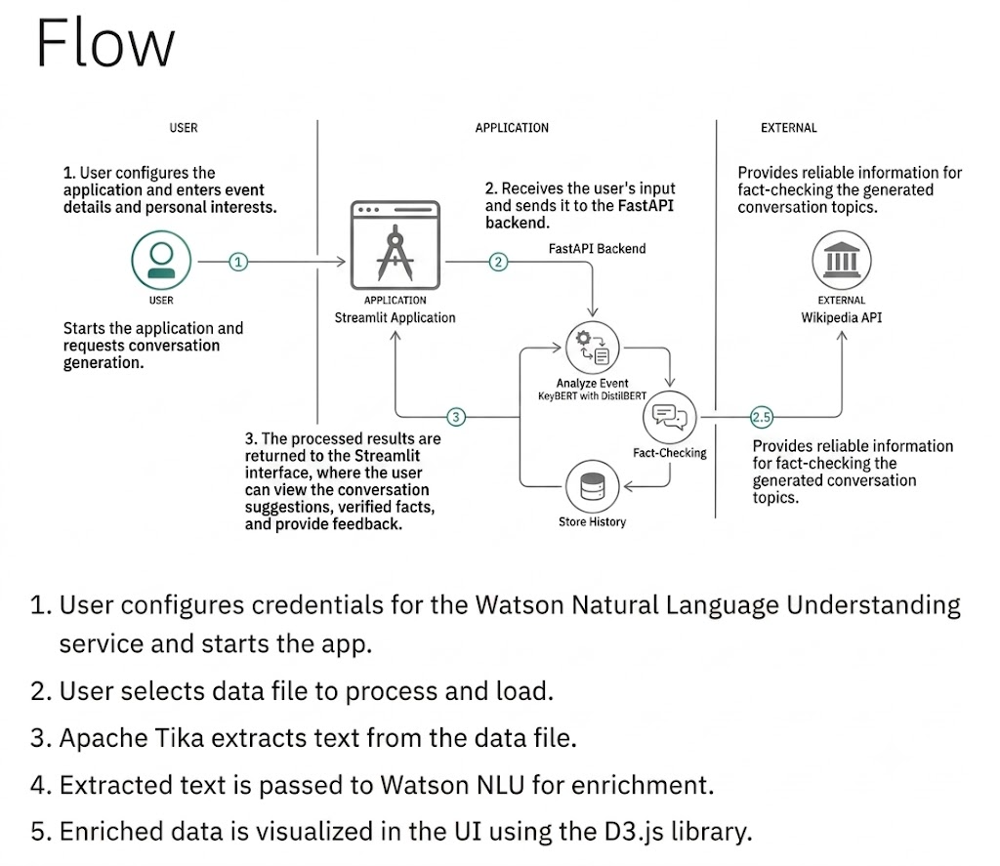
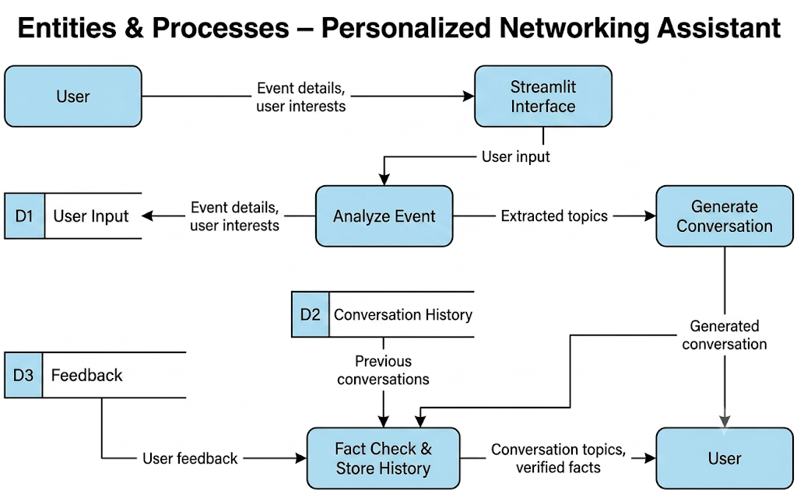

User Stories
Use the below template to list all the user stories for the product.
User Type | Functional Requirement (Epic) | User Story Number | User Story / Task | Acceptance criteria | Priority | Release
User | Event Input | USN-1 | As a user, I can enter event details and my interests. | The system accepts the input successfully. | High | Sprint-1
User | Topic Generation | USN-2 | As a user, I can generate personalized conversation topics. | Relevant conversation topics are displayed. | High | Sprint-1
User | Fact Checking | USN-3 | As a user, I can view fact-checked information related to the generated topics. | Verified facts are displayed with the results. | High | Sprint-1
User | Conversation History | USN-4 | As a user, I can view previously generated conversations. | Previous conversations are stored and displayed. | Medium | Sprint-2
User | Feedback | USN-5 | As a user, I can provide feedback on the generated conversation. | Feedback is successfully saved in the system. | Medium | Sprint-2
Administrator | System Management | USN-6 | As an administrator, I can monitor the application's performance and data. | System data and logs are accessible for monitoring. | Low | Sprint-3

